Making Friction Less
Friction can be reduced by:

Reasons for reducing friction:

Picture | What is the object called | How is friction reduced? | Why is friction reduced?
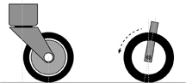
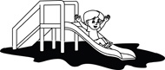
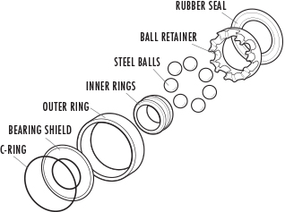
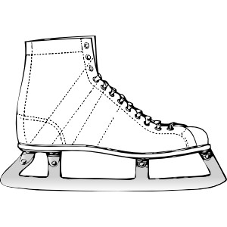
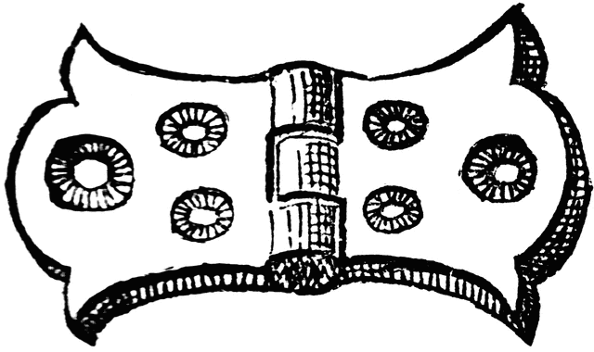 | Door  hinge
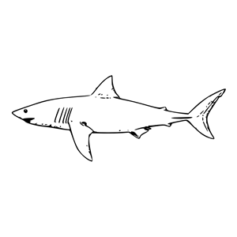

Making Friction More
How is friction increased?

Reasons for increasing friction:

Picture | What is the object called | How is friction increased? | Why is friction increased?
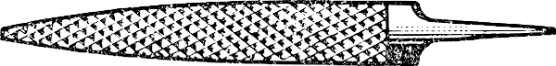
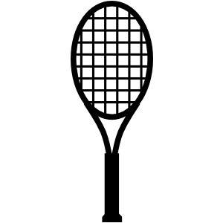

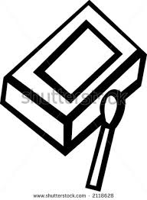
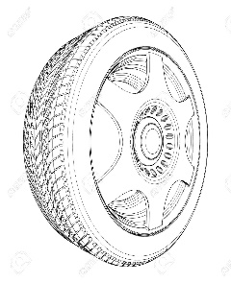 | Tire  tread


